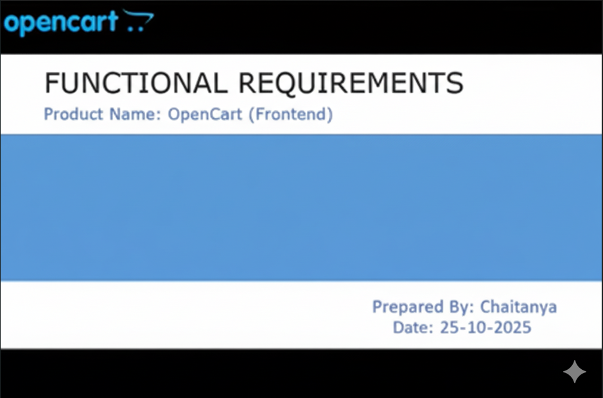
Overview:-
OpenCart is free open source e-commerce platform for online merchants. OpenCart provides a professional and reliable foundation from which to build a successful online store. This foundation appeals to a wide variety of users; ranging from seasoned web developers looking for a user-friendly interface to use, to shop owners just launching their business online for the first time. OpenCart has an extensive amount of features that gives you a strong hold over the customization of your store. With OpenCart's tools, you can help your online shop live up to its fullest potential.
Requirements:-
OpenCart requires certain technical requirements to be met for the store to operate properly. First, a web server must be created to make the OpenCart store publicly on the web. Domain names and hosting service can be easily be purchased for an affordable price.
When selecting a hosting service, you should check to see that these server requirements are provided and can be installed on their web servers.
These extensions must be enabled for OpenCart to install properly on the Web Server.
- PHP 5.4
- jQuery 2.1.1
- JavaScript
- Database (MySQL suggested)
- Web Server (Apache suggested)

OpenCart Frontend:-
This document is intended to be used as an introduction to the OpenCart default store front. The store front reveals how the customer views and interacts to the store.

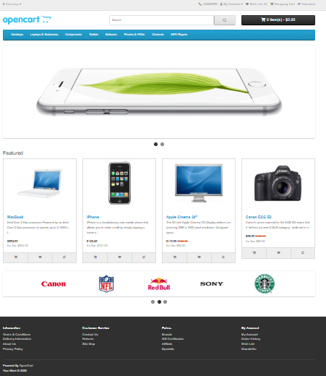

The products sees above are included as sample data with the OpenCart Installation. These products can easily be removed and replaced with the shop’s products later.

Navigating the Shop:-
The OpenCart default theme makes navigating a shop’s products easily accessible to it’s customers.

1.Home Page:-
The home page is arguably the most important page in the shop, in terms of presentation. In most cases, this will be the first page that a customer interacts with (especially if they are directed to the store site from a search engine). The shop’s homepage needs to be user-friendly, while at the same time highlighting the shop products.
The first step is becoming familiar with the store-front is understanding the anatomy of the OpenCart Default Homepage.
  - The Header:-
The header will display at the top of the page of the store; not just the home page.
The header has the following navigation options:-
- Store Logo:- Click on the store logo will direct the customer back to the homepage of the store.
- Currency Block:- The customer can select which currency the store’s products will be in by clicking on any of the currency icons.
- Shopping Cart:- Displays the number of items purchased, and the total price of the order. Clicking on the button will containing all the products added to the cart and an option to “View Cart” or “Checkout”.
- Search Box:- The customer can type in the search box to search for a product within the store’s product categories.
- Phone Number (123456789):- Provides customers with a direct contact number for inquiries or support.
- My Account:- Allows users to log in, view, and manage their personal account details and orders.
- Wish List:- Enables customers to save desired products for future viewing or purchase.
- Checkout:- Directs users to finalize their purchase and complete the payment process.

  - The Top Menu:-
The top menu category only displays the top parent categories of products.
Like the header, the top menu will be displayed on every page. When the customer’s mouse is dragged over a category, a drop-down menu will display the sub-categories for that parent category.
When a parent category is clicked, the customer will be directed to the category page, which displays all the products within the category.
  - Slideshow:-
The slideshow displays several products banners of your choice by alternating the images in a slideshow. After a certain amount of time, one banner will shift to the next banner. Banners in the slideshow are useful for highlighting certain products to be easily accessible by the customer. When the banner is clicked on, the customer will be redirected to the product on the banner’s page.
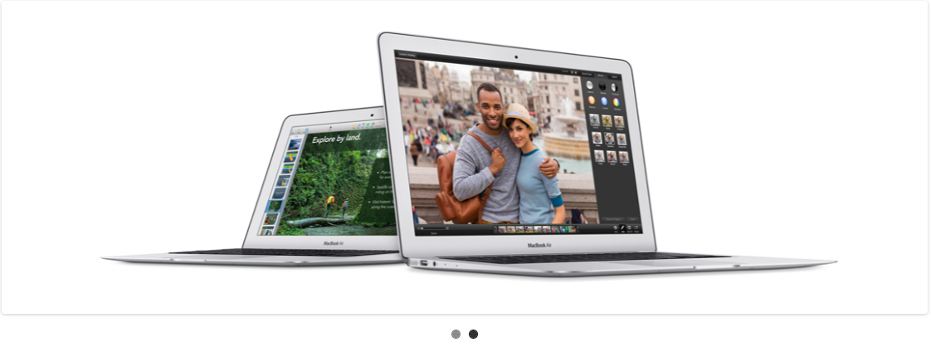
Unlike the top menu and header, the slideshow in the OpenCart default can only be viewed on the home page in this position.
  - Featured Products:-
OpenCart gives you the option of featuring specific products of their choosing on the home page.
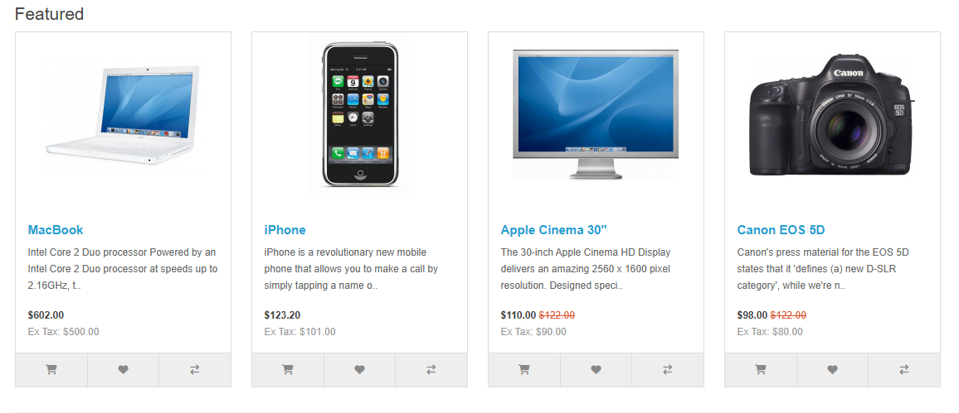
The Featured Section includes the product image, name and price and an option to add the product directly to the shopping cart.
  - Footer:-
The footer is located at the bottom of every page, not just the Home Page. This block of miscellaneous links is useful in sorting relevant pages for the customer that may not logically sort anywhere else.
The organizational scheme of the footer can be divided into the following sections.
- Information:- “About Us”, “Delivery Information”, “Privacy Policy”, “Terms & Conditions”.
- Customer Service:- “Contact Us”, “Returns”, “Site Map”.
- Extras:- “Brands”, “Gift Vouchers”, “Affiliates”, “Specials”.
- My Accounts:- “My Account”, “Order History”, “Wish List”, “Newsletter”.
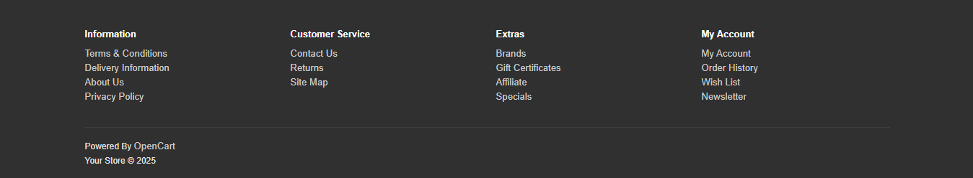

Product Pages:-
The OpenCart default product page will follow the structural format seen below.
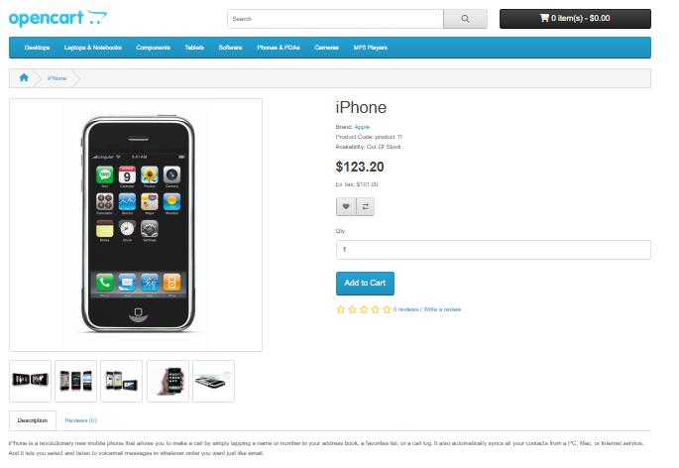
The product page can be divided into the following sections:-
- Product Image:- The product image can be displayed under the title on the left-side, along with alternate views of the product underneath it in smaller box. Clicking on the main image will expand the image within the window for the customer to see it in greater detail.
- Product Details:- The product code, availability and price are displayed just right to the product image.
- Cart:- The customer can select a quantity and add the product to their cart, Wish List or compare.
- Rating / Sharing:- Underneath the cart can rate the product and / or share the product on different social media sites.
- Description Tab:- An area underneath the main product information to provide a detailed description of the product.
- Review Tab:- An area for the customer to write a review on the product.
Category Products Listing:-
Category Products Listings enables customers to browse products similar to other products within the same category. This is especially helpful for customers looking to compare products, a feature that will be explained under Categories. The category page can be accessed a number of ways. It can be accessed from the top menu, when a customer clicks on one of the parent categories. Also on product pages, a customer can access the category product listing page by clicking on a category on the left side category block.
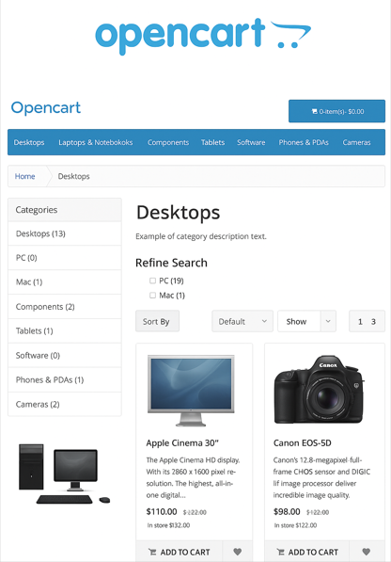
As seen above, the category block is displayed on the left-side like it is in the product page. There is a space under the category title at the top to add a description to the category. The “Refine Search” links to sub-categories of that category for the user to browse. The products can be displayed according to the customer’s preference: in a list or grid. The above image is sorted in the listing format. The products can be sorted according to name, price, rating or model in the “Sort By” box. The numbers of products displayed in the product listing can be changed in the “Show” from 15 to 160.
There is a section that gives space for each products within the category, providing a product image, description, price and an Add to Cart option. There is an option to add a product to a Wish List. Another option for the product is “Add to Compare”.
Product Compare:-
“The Add to Compare” feature in the product section allows the customer to compare the different specifications, features and price of a number of products he might be interested in.
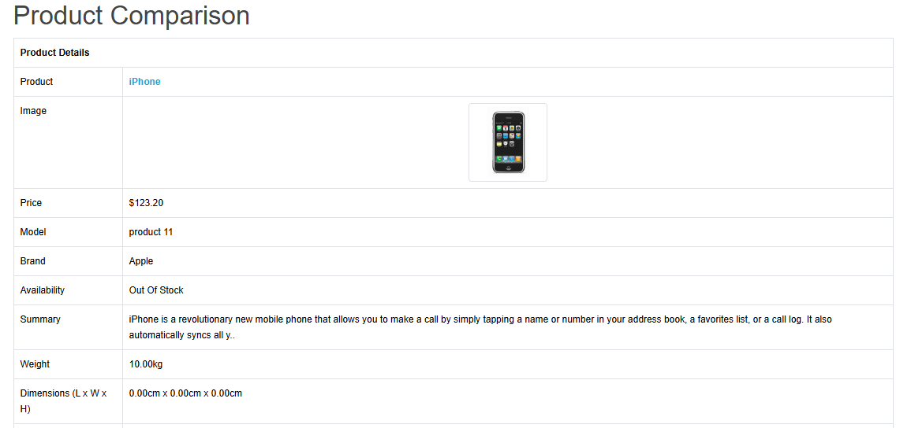

Add to Cart:-
The "Add to Cart" functionality is present in multiple locations to allow customers to easily select and purchase products:
- Featured Products: On the Home Page, the "Featured Products" section includes an option to add the product directly to the shopping cart.
- Product Pages: On a specific Product Page, the "Cart" section allows the customer to select a quantity and add the product to their cart.
- Category Products Listing: On the Category Products Listing page, there is a dedicated section for each product that provides an Add to Cart option.
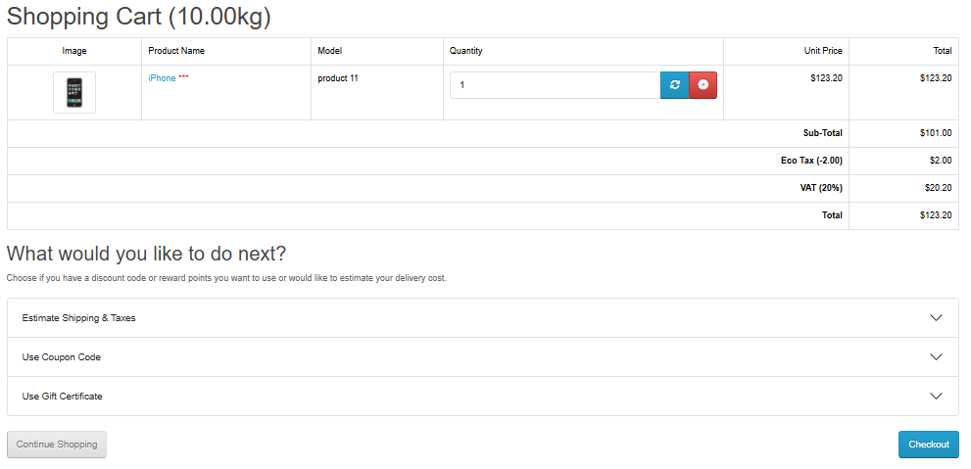
Checkout Section:-
The "Checkout" process is the final step where the customer completes their purchase:
- Header: The Shopping Cart icon/button in the header displays the number of items and the total price. Clicking on this button shows all products added to the cart and an option to "Checkout".
- Header: The "Checkout" link is also listed as one of the direct navigation options in the header, which directs users to finalize their purchase and complete the payment process.

